BROOKFIELD HERITAGE COMMISSION COFFEE
CHURCHILL SCHOOL

Join the Heritage Commission for another in our series of Saturday morning coffees, at 10 AM at the Brookfield Town House. Judy Meakin, a lifelong resident of Brookfield, will talk about attending the Churchill School as a child.
Churchill School was built in 1801 on property that was owned by Nathan Watson’s land on Moose Mountain Road at a cost of $117.
Judy will walk us through a day at Churchill School and her favorite teacher, Mrs. Eva Willey. Judy has called her the most influential person in her life. Mrs. Eva Willey was a teacher far ahead of her time. Come and find out why.
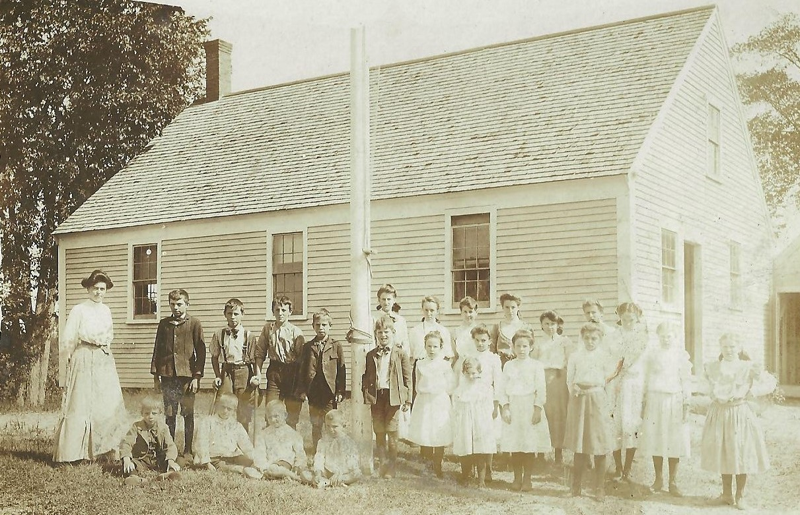
Photo below: Churchill School, September 10, 1905, the teacher is Alice Churchill.

